***Recruitment Management System***

**PROJECT REPORT**

Submitted in partial fulfillment of the requirements

For the award of the degree of

Bachelor of Technology

(Computer Science and Engineering)



Guide: Submitted by:

Dr. Narender Kumar Rawal Avinash Karhana

(2016-2020)

Department of Computer Science and Engineering

Hemvati Nandan Bahuguna Garhwal University

(A Central University)

Srinagar (Garhwal) - 246174

Contents

Chapter 1: Introduction 1

1.1 Aim: 1

1.2 Scope 1

1.3 Overview 2

Chapter 2: Literature Survey 3

2.1 What for Web Server? 3

2.1.1 Options Available 3

2.1.2 What I choose? 3

2.2 Selection of web technology 3

2.2.1 Options Available 3

2.2.1 What I choose? 3

2.3 Database Management Selection 4

2.3.1 Options Available 4

2.2.1 What I choose? 4

Chapter 3: System Analysis 5

3.1 Existing System 5

3.1.1 Cons of existing system 5

3.1 Proposed System 5

3.1.1 Pros of proposed system 5

Chapter 4: System Requirements 6

4.1 Hardware specifications 6

4.2 Software specifications 6

Chapter 5: Design 7

5.1 User Interface 7

5.2 Modules 8

5.2.1 Registration module 8

5.2.2 Forgot Password Module 9

5.2.3 Advertisement Module 10

5.2.4 Non-admin User panel 11

5.2.5 Document upload module 12

5.2.6 Post Application Module 12

5.3 Database Design 14

5.4 Data-flow Diagram 15

Chapter 6: Testing 15

6.1 Unit Testing 16

6.1.1 Registration module 16

6.1.2 Forgot password module 16

6.1.3 Authentication Module 17

6.1.3 Document Uploading Module testing 19

6.1.4 Post Application Module testing 20

6.2 Integrated Testing 22

Chapter 7: Conclusion and Further enhancements 24

7.1 Future Enhancements 24

Chapter 8: References 25

# Chapter 1: Introduction

## Aim:

The purpose behind this project i.e. Recruitment Management System was to develop a system that can make procedure of recruitment more convenient and transparent.

To provide candidates the convenience to apply for different posts under one single portal and login-based web application and time cutting facility to auto shortlist candidates for interview on basis of complex mathematics and score calculated on basis of details provided by the applicant.

## 1.2 Scope

In the procedure of recruitment there is a whole a lot more complexions as it seems to be. To maintain all the efficiency this task is a whole new challenge with all that transparency in procedure for fair selection of applications. For this we have scope for this new proposed system as follow

* Providing a single web-based portal for various type of recruitment.
* Making the procedure and shortlisting open to applicants.
* Reducing errors and increasing efficiency of calculations.
* Lessening manpower needs in whole procedure.
* Managing all the intermediate tasks with full accuracy.



Figure 1: Recruitment Management System

## 1.3 Overview

This project will provide a full fledge system to automate recruitment procedure with management level controls.

Including some important and powerful features that are essential for the process and have benefits as time saving, better resource management, less manpower, high accuracy, high transparency in process and a lot more.

Some features are:

* Document uploading Module for verification purpose
* Auto-Short listing for interview on basis of score calculation as per criteria

Etc.

# Chapter 2: Literature Survey

## 2.1 What for Web Server?

Whenever it comes to web server applications there are numerous options available in the market.

### 2.1.1 Options Available

* Microsoft Web Server
* Apache
* Tomcat

### 2.1.2 What I choose?

For this purpose, I choose Apache as from research I found a large community support for timely updates and any kind of problems and help, but over all this is an open source server software so no cost at all for its use for any purpose.

## 2.2 Selection of web technology

There are many scripting languages available in the market.

### 2.2.1 Options Available

* VBScript
* Perl
* JSP (Java Server Pages)
* ASP (Active Server Pages)
* PHP (Hypertext Pre-processor)

### 2.2.1 What I choose?

My selection for this project is PHP. As it serves all necessary features required in this web-based management service. At the same time, it is free for use in any form without any license requirement for use.



Figure 2: PHP as web development technology

## 2.3 Database Management Selection

There are a variety of database management system available.

### 2.3.1 Options Available

* Microsoft Access
* Microsoft SQL
* Oracle
* MySQL.

### 2.2.1 What I choose?

As per project needs we need a DBMS that is available easily free for use and at the same time can handle large amount of data efficiently. And among available resources in market I choose MySQL as its free for any kind of use and it’s a robust DBMS currently used by many large-scale organization.



Figure 3: MySQL for Database Management

# Chapter 3: System Analysis

## 3.1 Existing System

There we have an existing web-based application that says online applications for the different posts in the different recruitments happening in university. Currently this system only serves online applications and no further calculations or short-listing.

### 3.1.1 Cons of existing system

1. Applicant have to apply for different posts individually with different registrations by filling up the same redundant details every time for another application.
2. It provides no facility for short listing the candidates on the basis of score criteria.
3. Serves just to collect data with no further managements.
4. No options available for uploading the supporting documents for the verification purpose
5. Less interactive.

## 3.1 Proposed System

The proposed system i.e. Recruitment Management System is a web-based management system covering all the facilities of the existing system and providing further enhancements to that.

### Pros of proposed system

1. No data redundancy as there will be only single registration and all applications for different recruitment and post can be done from this one-time registration.
2. Time saving facility to auto shortlist candidates for interview on basis of complex mathematics and score calculated on basis of details provided by the applicant.
3. Management level controls available.
4. Options available for uploading the supporting documents for the verification purpose.
5. Reduces manpower needs which were previously needed for calculation verification and other manual tasks.
6. Auto notifications to shortlisted candidates on their web login.
7. Score and shortlisting transparency for all applicants.
8. More interactive and user friendly. (can be accessed from any web browser)

# Chapter 4: System Requirements

## 4.1 Hardware specifications

The machine specifications to serve this web-based application (with optimum output) on organization side are as follow

* A Computer as server with
  + i3 based or above processor
  + 1GB of RAM
  + 500 MB free Disk Space (Application installation)
  + High speed internet connection (4-5 MB/s recommended) with no port restrictions for running services
  + HDD as per data storage requirement (Approx. 10485 images of 100kb can be stored in 1GB storage)

## 4.2 Software specifications

The specifications to serve this web-based application on organization side are as follow

* Web server and DBMS control and maintenance application. (Can choose from xampp, wampp, etc.)
* Apache Web Server
* MySQL DBMS

On User side software requirements are just a “Web Browser” with an internet connection.

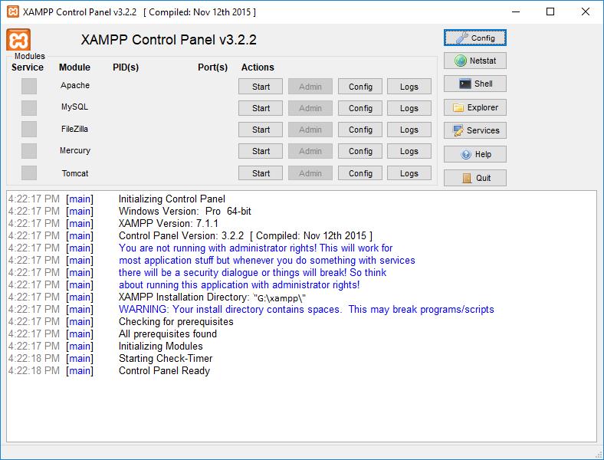 Figure 4: Snapshot of xampp management console

# Chapter 5: Design

## 5.1 User Interface

The primary objective of application is providing simplicity to user without compromising security of their data. For that purpose, I made a minimalist design for first interface with a login screen and other options like recent adverts, new registrations, forgot password etc.

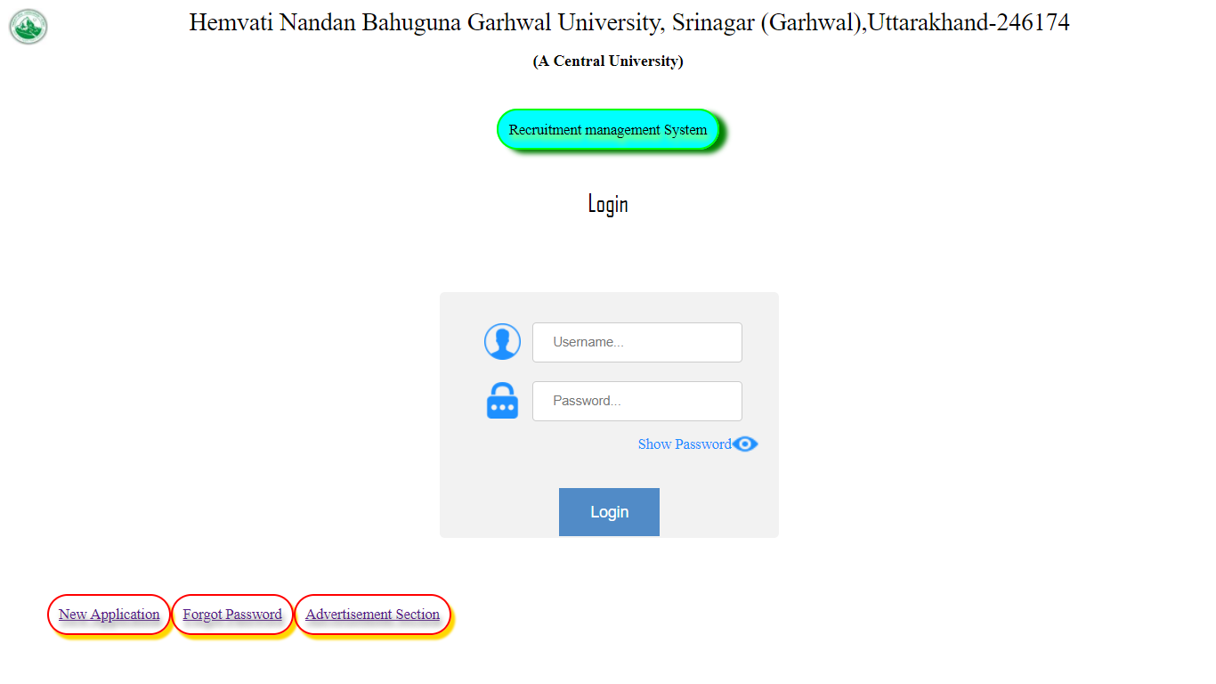

Figure 5: Snapshot of user interface.

From this interface a user can login to their respective accounts that provides security to their data and from other options can access registrations, advertisements and other services like password recovery for non-admin accounts.

So, for all this would be first interaction for all users to the system for accessing different modules of system to obtain optimum output from this management system.

## 5.2 Modules

Whole project works on different modules as

### 5.2.1 Registration module

There is registration module from which a new applicant can register from by filling up necessary details like name uidai (Aadhar), mobile number, email, etc.

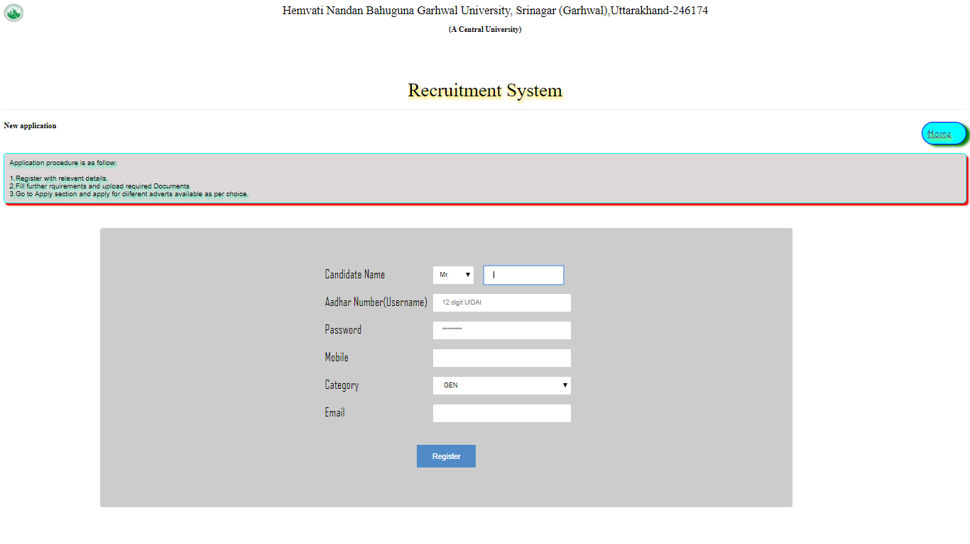

Figure 6: Snapshot of Registration Module

### 5.2.2 Forgot Password Module

There is “forgot password” module from which a non-admin user can recover lost password by validating necessary details like uidai (Aadhar) and mobile number.

Initail look

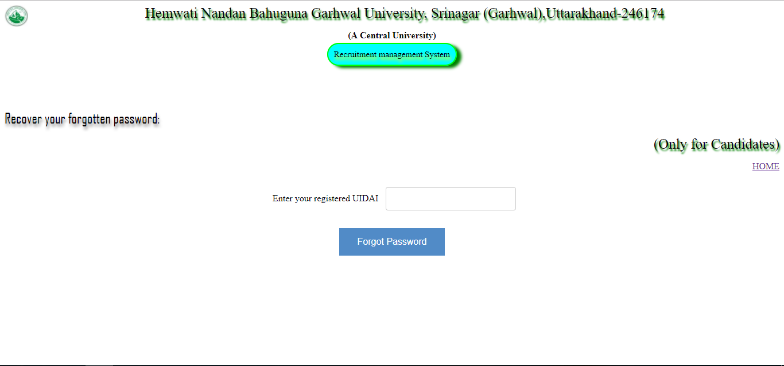 Figure 7: Snapshot of Forgot Password Module first interface

After submitting UIDAI

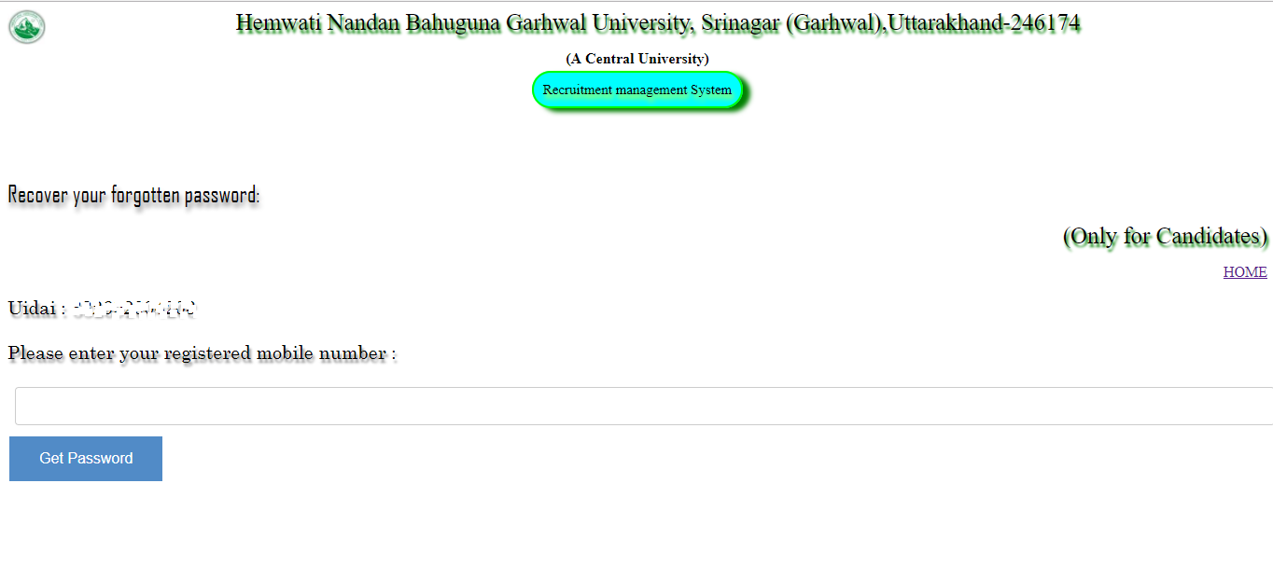

Figure 8: Snapshot of Forgot Password Module second interface

### 5.2.3 Advertisement Module

There is “Advertisement Section” module from which an applicant can look for different advertisements that may be open for application or closed as per date.

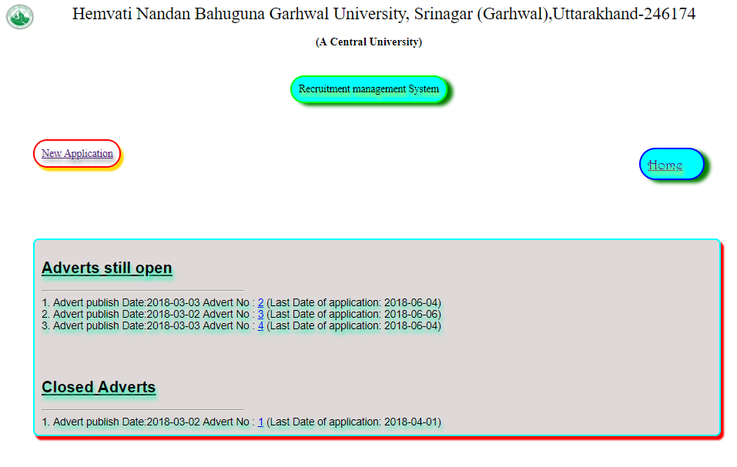

Figure 9: Snapshot of Advertisement Module

In this module by clicking advert number a user can read full advertisement.

### 5.2.4 Non-admin User panel

There is user panel for all those who registered on system.

For applicants/candidates there is a panel in which they can enter their details that could be needed in applying for different posts. For e.g. Personal details, Educational details, Book Publication details, Research details (papers and projects), Experience details, etc.

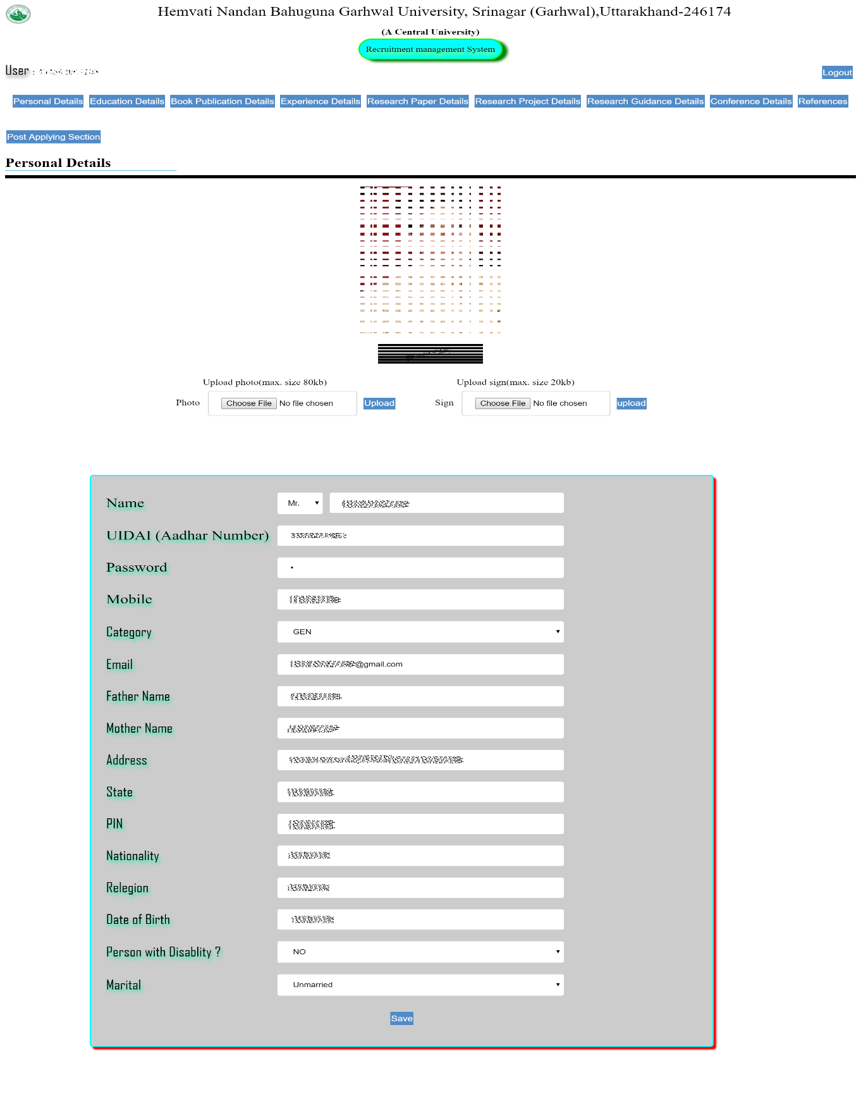 Figure 10: Snapshot of Non-Admin User Panel

### 5.2.5 Document upload module

This module is for uploading the supporting documents for the verification purpose.

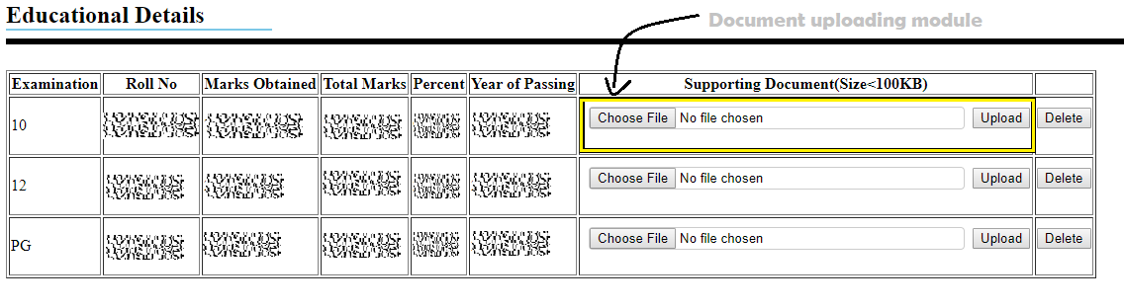Figure 11: Snapshot of Document uploading Module in Educational detail section

### 5.2.6 Post Application Module

This Module is to apply for different posts available under different adverts till date.

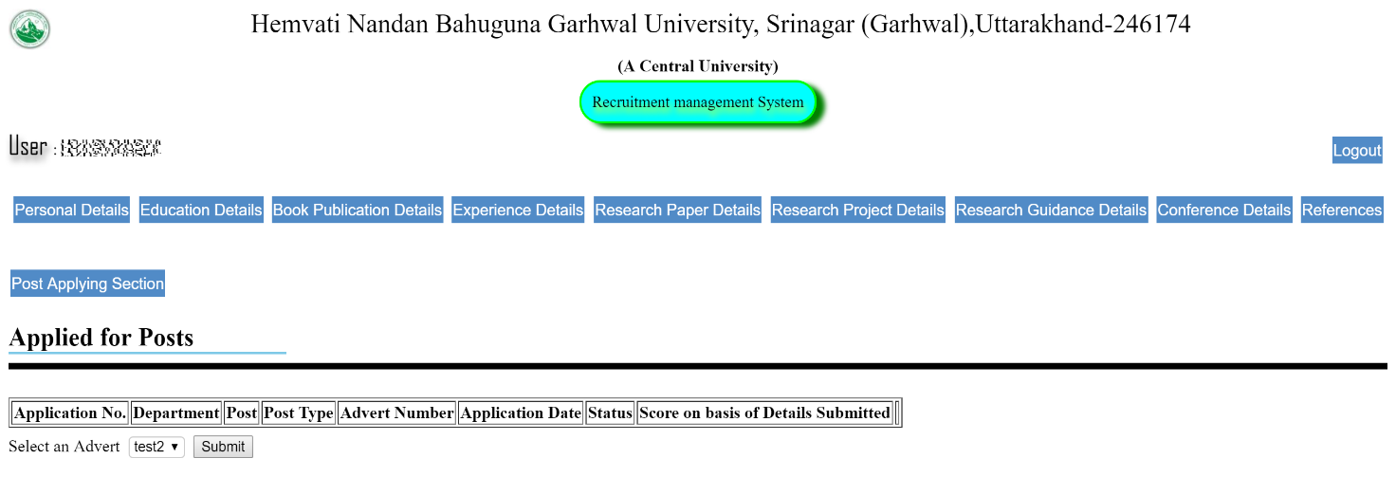Figure 12: Snapshot of Post Application Module

Here user selects from different adverts available.

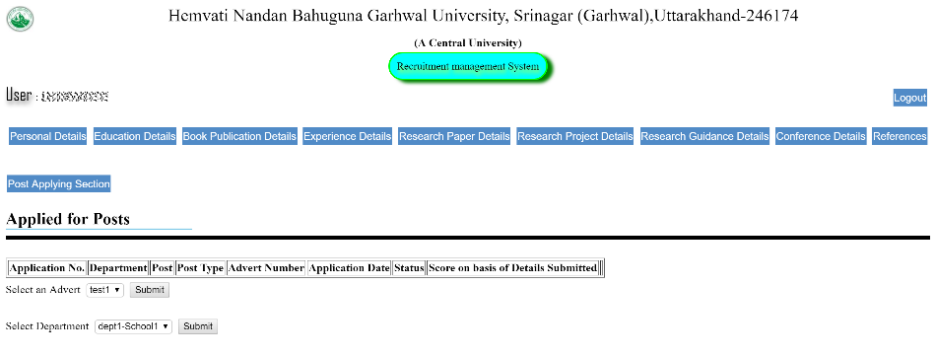

Figure 13: Snapshot of Post Application Department selection

Here user selects from different departments to apply in from selected advert.

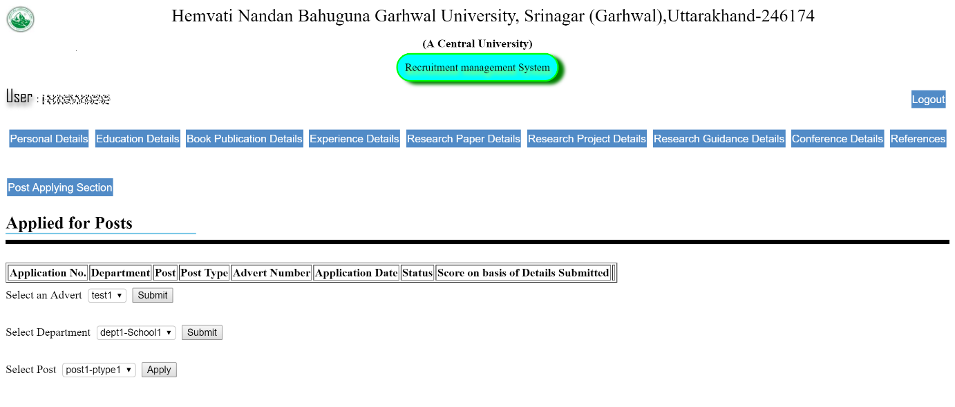

Figure 14: Snapshot of Post Application selecting post

Here user select post to apply in selected department under selected advert.

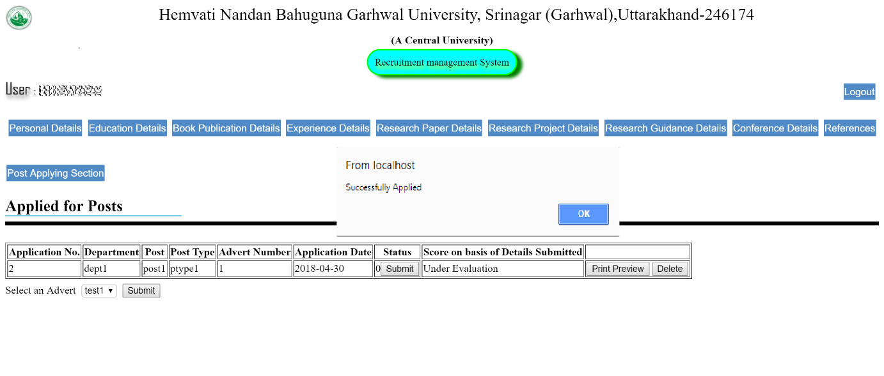

Figure 15: Snapshot of Successful post application in module.

Here user successfully applied for selected post.

## 5.3 Database Design

Database is designed as per following schema

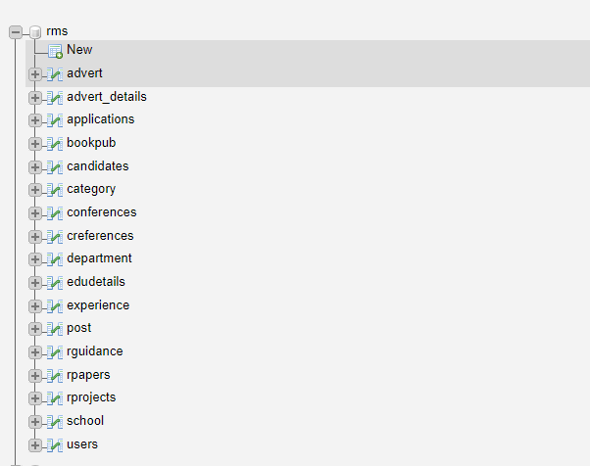

Figure 16: Database Structure.

After expanding tables

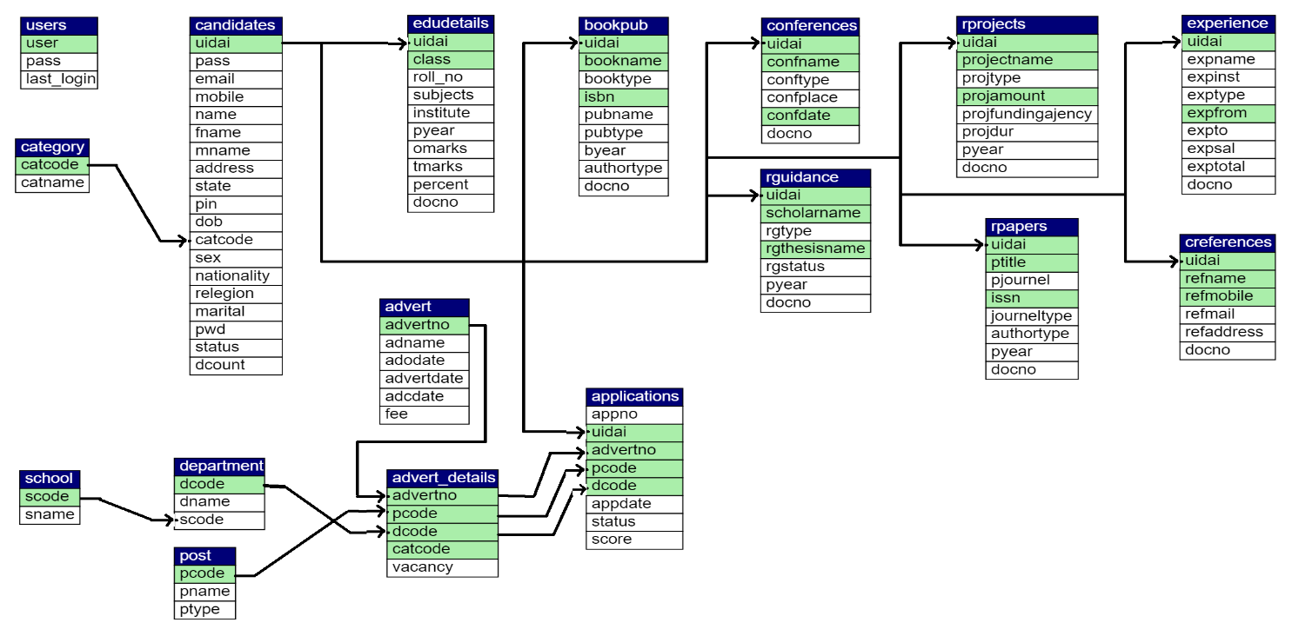

Figure 17: Database Relation Model.

## 5.4 Data-flow Diagram

User Panel

Failed

# Chapter 6: Testing

Authorized

Failed

No

Yes

Verification

Shortlisting

Reports

Admin Panel

Admin

User

Notifications

Score Evaluation

Application

Details Submission

Login

## 6.1 Unit Testing

It is modular testing phase with some specific test cases as

### 6.1.1 Registration module

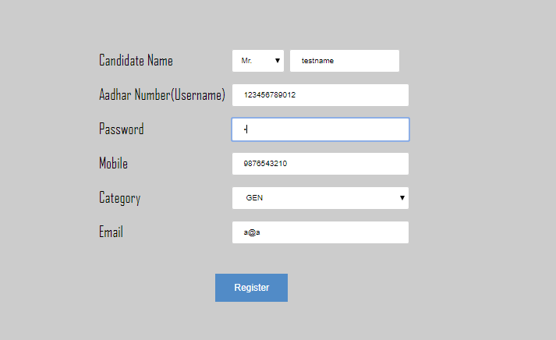

Figure 18: Register module Testing

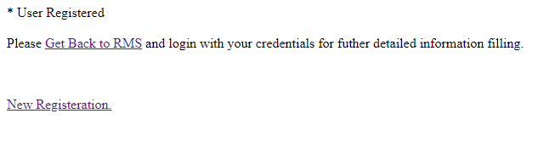

### 6.1.2 Forgot password module

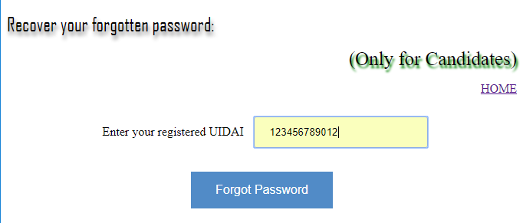

Figure 19: Password recovery module Testing

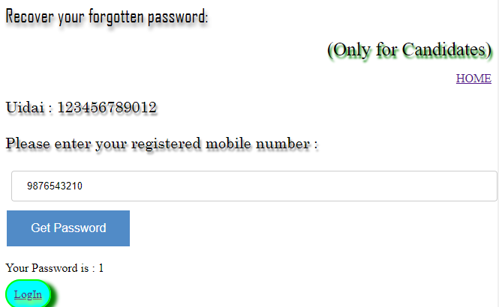

Figure 20: Password Recovery by correct mobile number

### 6.1.3 Authentication Module

#### 6.1.3.1 For Correct Details

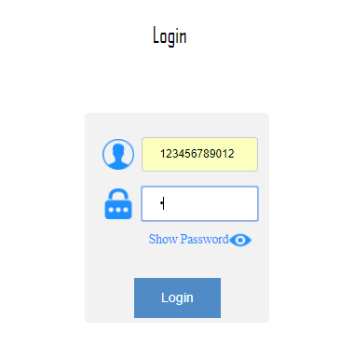

Figure 21: Authentication with correct userid and password 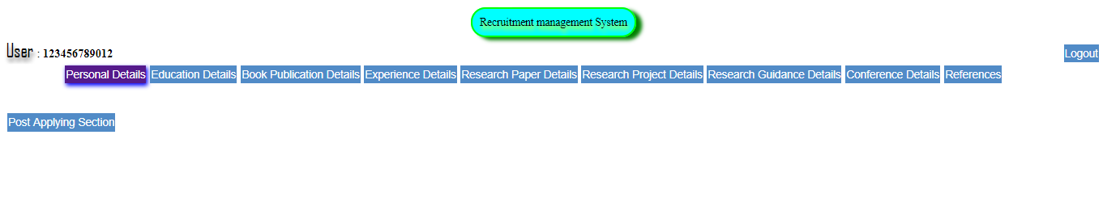

Figure 22: Login Success output as user panel

#### 6.1.3.2 For Wrong password

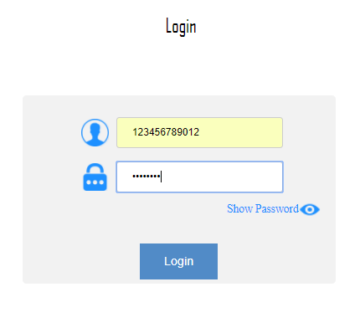

Figure 23: Authentication testing with wrong pass

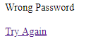

#### 6.1.3.3 For wrong userid

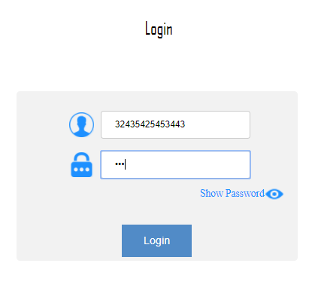

Figure 24: Authentication testing with wrong userid



### 6.1.3 Document Uploading Module testing

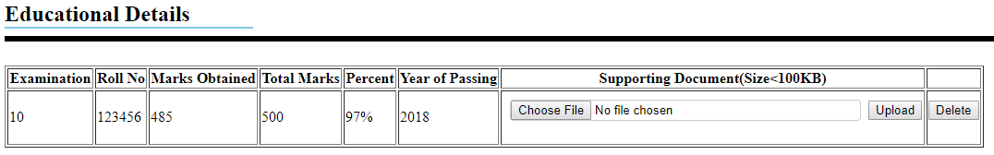

Figure 25: Document Uploading module testing: file selected

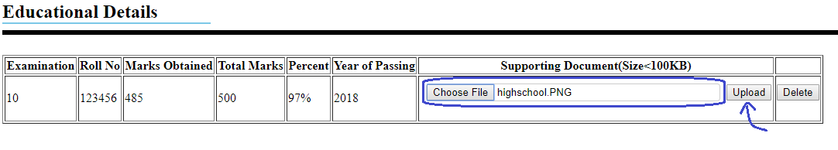

Figure 26: Document Uploading module testing: file selection for upload



Figure 27: Document Uploading module testing: Uploaded

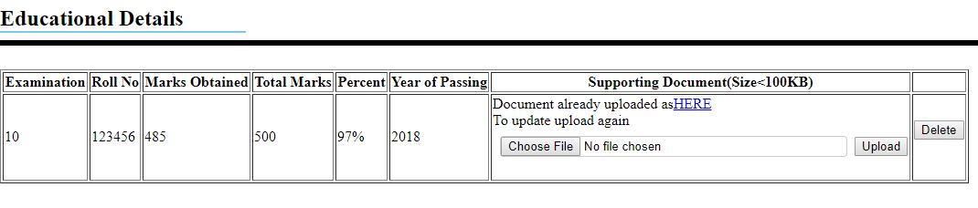

Figure 28: Document Uploading module testing: Update notification

### 6.1.4 Post Application Module testing

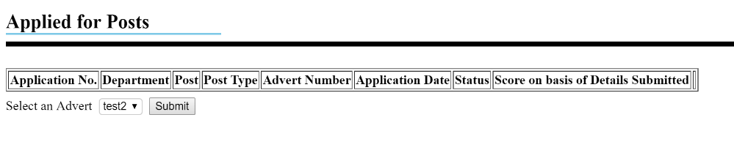

Figure 29: Application module testing

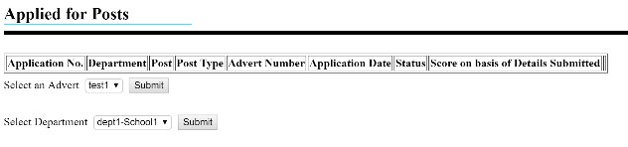

Figure 30: Application module testing after selecting an advert

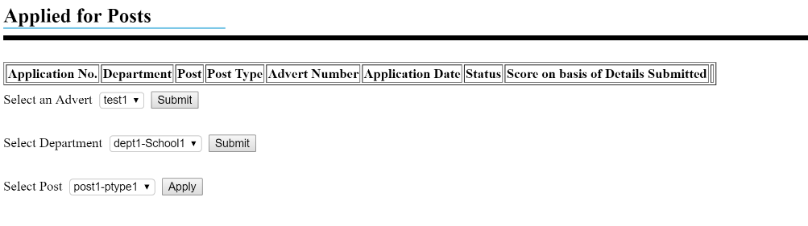

Figure 31: Application module testing after selecting department as per advert and then finally selecting post to apply for

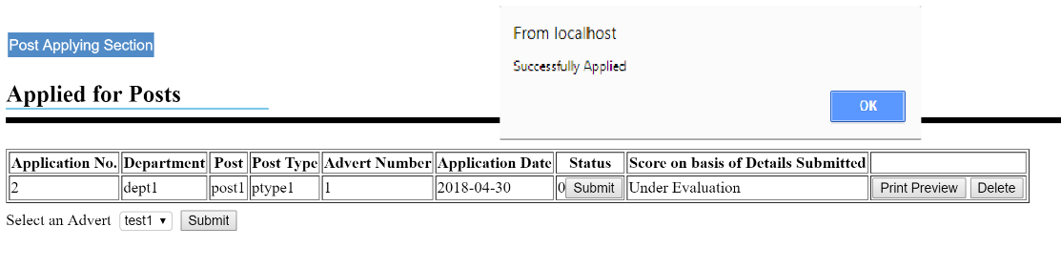

Figure 32: Application module testing: Successfully applied

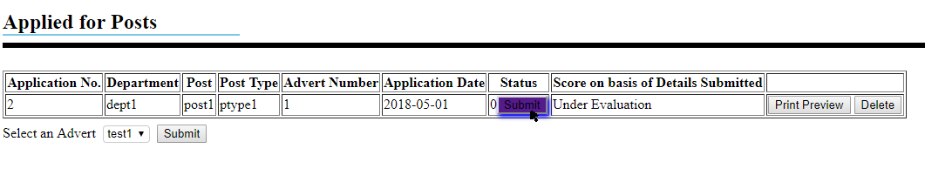

Figure 33: Application module testing: Submission

## 6.2 Integrated Testing

With a test case

* Name: testcase1
* Sex: male
* Mobile: 1111111111
* Email: test1@test1
* Category: GEN
* Email: test1@test1
* Father Name: Abc1
* Mother Name: Pqr1
* Address: zxc
* State: mnb
* PIN: 111111
* Nationality: Indian
* Religion: poi
* Date of Birth: 1997-05-01
* Person with Disability? NO
* Marital: Unmarried

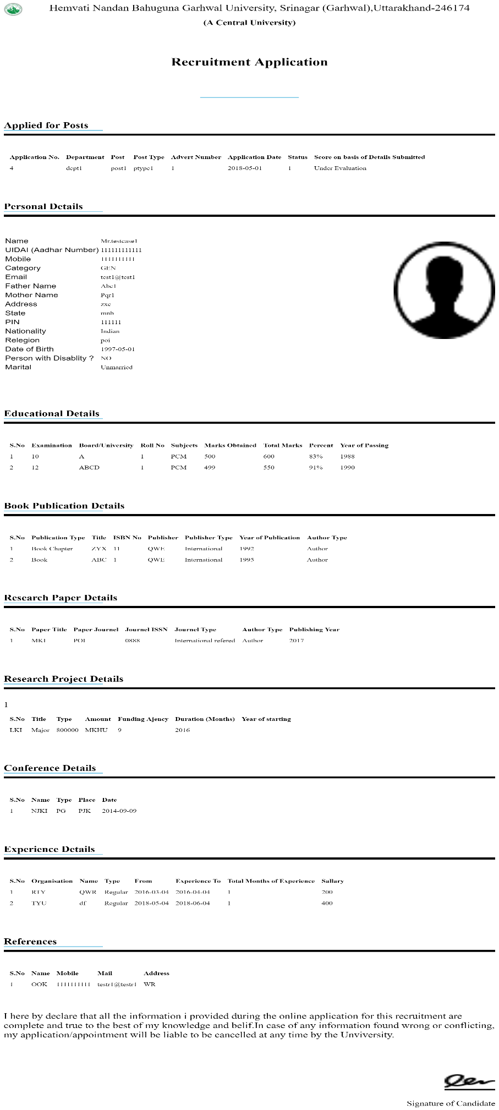

Figure 34: Integrated testing

# Chapter 7: Conclusion and Further enhancements

At last the project Recruitment Management System is a fruitful step towards effective processing in terms and regards of recruitment.

This provides a simple user interface hiding in behind complexions and increase the productivity of overall process by saving resources and time.

Provide anywhere access to web-application and provide numerous facilities that were not present in previous existing system like shortlisting of candidates, document uploading module etc.

## 7.1 Future Enhancements

There can be future the enhancements in the project like

* Including stage 1 examination portal
* Linking to the Future employee management system

And many more.

# Chapter 8: References

* Managing And using Information System
  + Keri E. Pearlson
* Management Information System TEXT & CASES
  + Waman S Jawadekar
* Google (<https://www.google.co.in/>)
* Wikipedia (<https://www.wikipedia.org/>)
* Journals-Elsevier (<https://www.journals.elsevier.com/>)
* Online Library Wiley (<https://onlinelibrary.wiley.com/>)